**Ma’lumotlar tuzilmasi va algoritmi**

**F.I.SH. Omonbayev Jaloliddin Ravshanbek o’g’li**

**Guruh: 911-21 guruh talabasi**

**Amaliyot: 5**

**Misol: 8**

**Dasturlash tili: C++ CodeBlocks**

**Savol:**  **Ikki yo‘nalishdagi iteratorlar** (biderectional_iterator) forward-iteratorlarning barcha xususiyatlariga ega, bundan tashqari, konteynerni ikkita yo‘nalishi bo‘yicha o‘tish imkonini beradigan qo‘shimcha dekrementa (--i, i--, *i--) operatsiyasiga doir misol ishlash.

№ 1

#include<iostream>

#include<list>

using namespace std;

int main()

{

list<int>v1 = {1, 2, 3, 4, 5};

list<int>::iterator i1;

for (i1=v1.begin();i1!=v1.end();++i1)

{

*i1 = 1;

}

for (i1=v1.begin();i1!=v1.end();++i1)

{

cout << (*i1) << " ";

}

return 0;

}

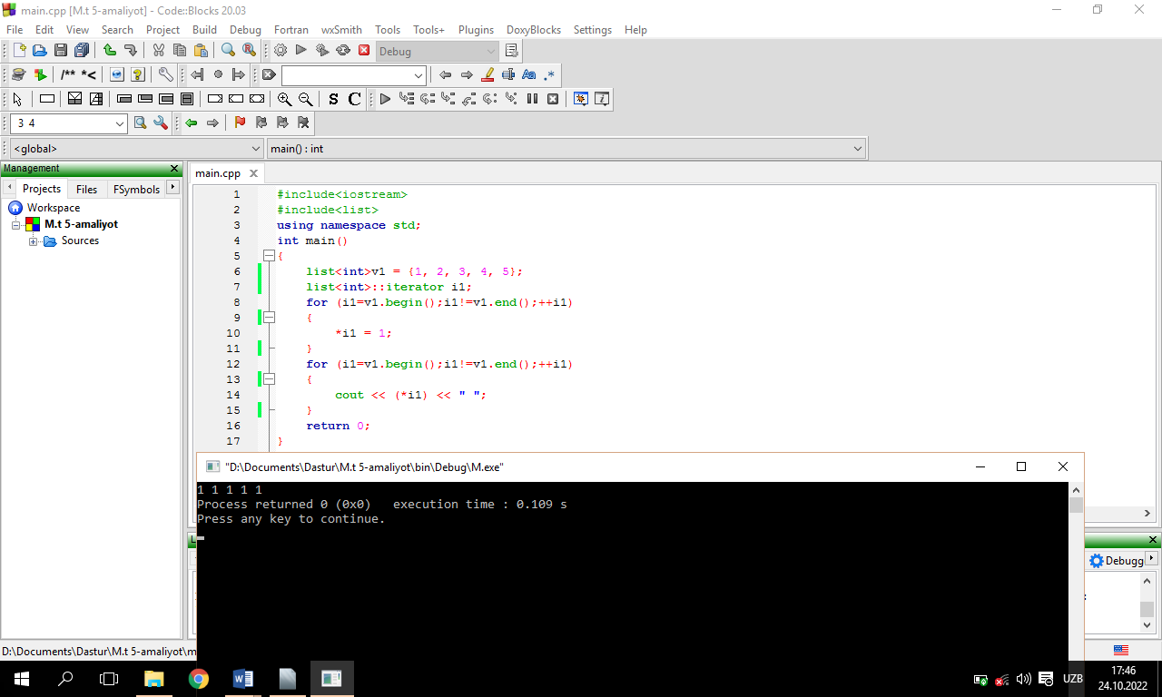

**№ 2**

#include<iostream>

#include<list>

using namespace std;

int main()

{

list<int>v1 = {1, 2, 3, 4, 5};

list<int>::iterator i1;

for (i1=v1.end();i1!=v1.begin();--i1)

{

if (i1 != v1.end())

{

cout << (*i1) << " ";

}

}

cout << (*i1);

return 0;

}

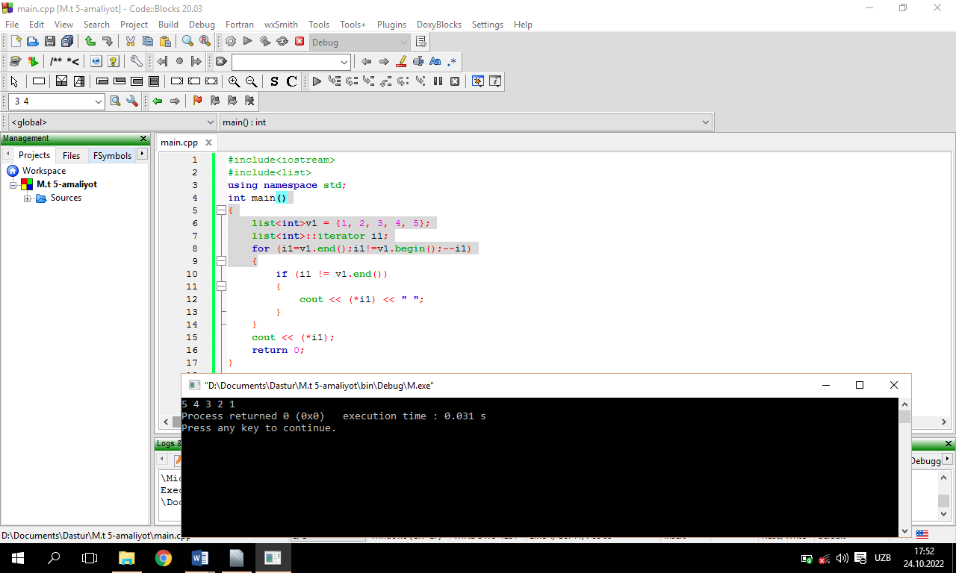

№ 3

#include <iostream>

#include<iterator>

#include<vector>

using namespace std;

int main() {

vector<int> vec{10, 20, 30, 40, 50, 60, 70, 80, 90, 100};

vector<int> ::iterator it;

vector<int> :: reverse_iterator rev_it;

for(it = vec.begin(); it != vec.end(); it++)

cout<<*it<<" ";

cout<< endl;

for(rev_it = vec.rbegin(); rev_it!= vec.rend(); rev_it++)w

cout<<*rev_it<<" ";

}

